Emily’s Trip to Las Vegas:

I’m going to start my day at The Venetian Resort Hotel and Casino. I am going to get their free breakfast to start my day. 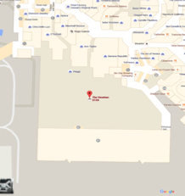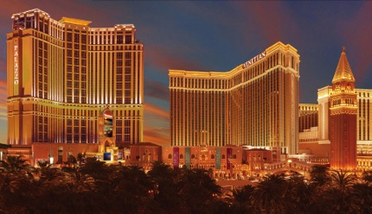
Stop 1: After I eat and pack my bag to leave, I am going Shark Reef at Mandalay Bay. They have exotic reptiles and awesome sea creatures. It takes you 11 minutes to get there by cab. Which is the best way to get to Shark Reef.
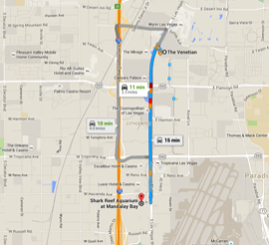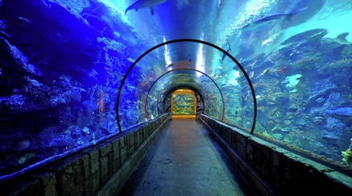
Stop 2: After I enjoyed all the animals I’m heading to The Fremont Street Experience. They are up in the air called an Air Mall. They have all different cool stores and have free entertainment inside. It will take 11 minutes by cab. This is the best way to get there.
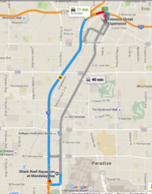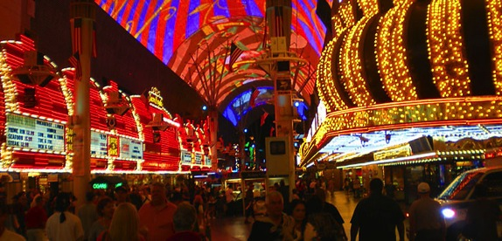
Stop 3: Next, I decided to go to the Adventure Dome. It is an inside amusement park with roller coasters and thrill rides. It will take me 9 minutes to get there from Fremont by cab. Which is the best way to get there.
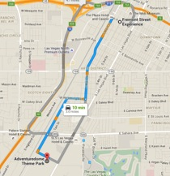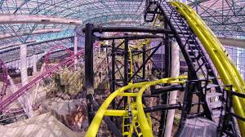
Lunch: My next stop is lunch. Thank goodness I’m hungry. I’m going to do to Le Cirque. It’s a cute little authentic Italian place. It will take 7 minutes by cab to get there from Adventure Dome. For lunch I’m going to get Le Poulet Rôti Aux Asparagus Et Chanterelles. Which is honey roasted chicken dish that served with mushroom sauce on the chicken, asparagus, and baby butter roasted potatoes. I will also get a soda and a water to drink.
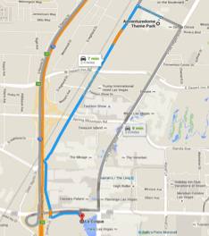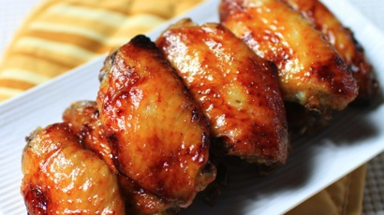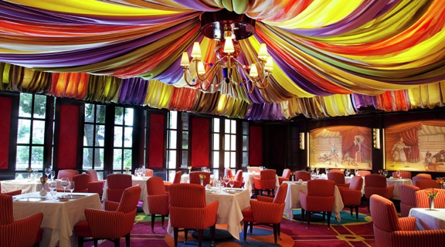
Stop 4: After I have lunch I’m going to ride the X-Scream at Stratosphere. This ride has a 866 feet high straight drop down. It is on top the Stratosphere building. It will take a while to get through the line so I won’t have to worry about losing my food, I hope. It will take us 8 minutes by cab to get there from lunch.
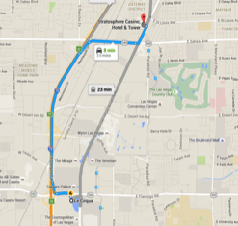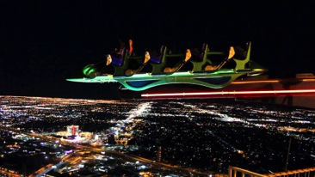
Stop 5: After I have ridden the X-Scream I’m going to the Dessert Breeze Aquatic Center to relax in the pool and hot tub for a few hours. Maybe even ride the slides a few times. It will take 10 minutes by cab to get there from the Stratosphere.
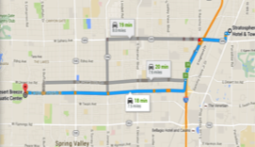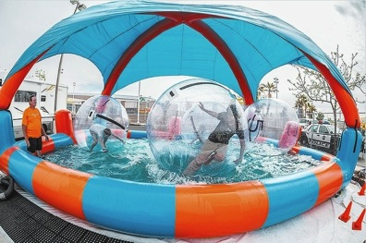
Dinner: After a fun day in Vegas I am ready to have dinner and go back to the hotel. I’m going to Texas De Brazil for dinner. They have all kinds of cool things to eat. I’m going to get Pork Ribs and a Soda. Then I might have dessert if I do I’m going to get Brazilian Cheesecake. I love cheesecake. From the water park it takes 19 minutes to get to dinner.
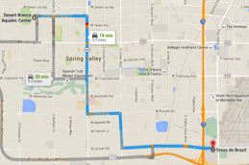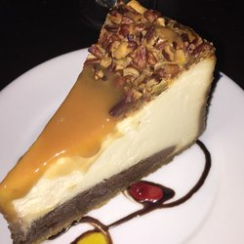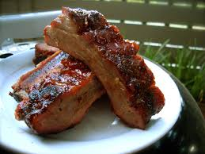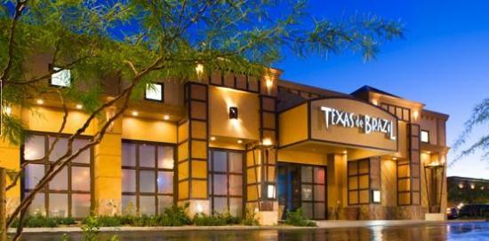
After a long day in Vegas, I’m finally ready to go back to the hotel and get ready for tomorrow. It takes 10 minutes to get back to my hotel.
